import pandas as pd
import numpy as np
import seaborn as sns
import matplotlib.pyplot as plt
import warnings
warnings.filterwarnings(action="ignore")
from sklearn.model_selection import train_test_split
from sklearn.metrics import accuracy_score, classification_report
from sklearn.ensemble import AdaBoostClassifier
from sklearn.neural_network import BernoulliRBM
from sklearn.preprocessing import StandardScaler
from imblearn.over_sampling import SMOTE
import tensorflow as tf
from tensorflow.keras.models import Sequential
from tensorflow.keras.layers import Dense
from sklearn import metrics
from sklearn.metrics import confusion_matrix
from sklearn.datasets import make_classification
from sklearn.metrics import accuracy_score, precision_score, recall_score, f1_score
#importing data from the dataset
df = pd.read_csv(r"C:\Users\agarw\OneDrive\Desktop\Dissertation\data.csv")
#checking for bankrupt companies 0 is non-bankrupt and 1 is bankrupt
bankrupt_data = df['Bankrupt?'].value_counts()
bankrupt_data
0 6599
1 220
Name: Bankrupt?, dtype: int64
#Distribution representation
plt.figure(figsize = (10,5))
ax = sns.countplot(df['Bankrupt?'])
ax.bar_label(ax.containers[0])
plt.title('Class Distribution \n (0:Financially Stable || 1:Financially Unstable)', fontsize = 14)
plt.show()
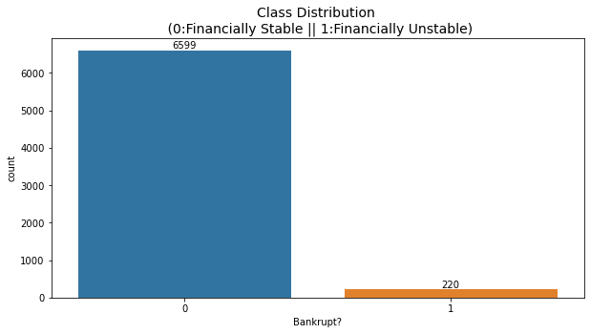
# seperate the Bankrupt label from the dataset
y = df['Bankrupt?']
X = df.drop(['Bankrupt?'], axis = 1)
# divinding our dataset into training dataset
X_train, X_temp, y_train, y_temp = train_test_split(X, y, test_size=0.2, random_state=42)
plt.figure(figsize = (10,5))
ax = sns.countplot(y_train)
ax.bar_label(ax.containers[0])
plt.title('Class Distribution \n (0:Financially Stable || 1:Financially Unstable)', fontsize = 14)
plt.show()
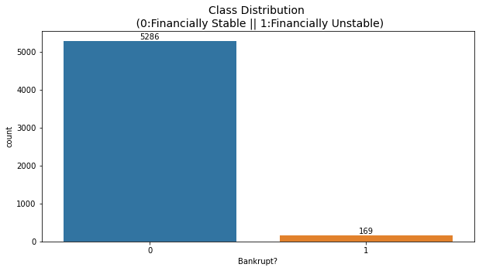
# divinding our dataset into testing and validation
X_val, X_test, y_val, y_test = train_test_split(X_temp, y_temp, test_size=0.5, random_state=42)
smote = SMOTE(sampling_strategy=0.25, random_state=42)
X_train_resampled, y_train_resampled = smote.fit_resample(X_train, y_train)
plt.figure(figsize = (10,5))
ax = sns.countplot(y_train_resampled)
ax.bar_label(ax.containers[0])
plt.title('Class Distribution \n (0:Financially Stable || 1:Financially Unstable)', fontsize = 14)
plt.show()
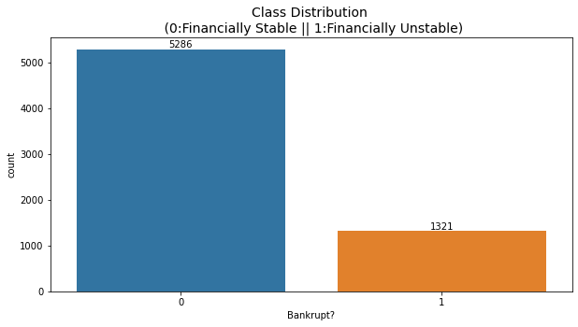
# Standardize the data
scaler = StandardScaler()
X_train_resampled = scaler.fit_transform(X_train_resampled)
X_val = scaler.transform(X_val)
X_test = scaler.transform(X_test)
rbm = BernoulliRBM(n_components=95, n_iter=5, random_state=42)
rbm.fit(X_train_resampled)
BernoulliRBM(n_components=95, n_iter=5, random_state=42)
# Transform the data using the trained RBM
X_train_transformed = rbm.transform(X_train_resampled)
X_val_transformed = rbm.transform(X_val)
X_test_transformed = rbm.transform(X_test)
model = tf.keras.Sequential([
tf.keras.layers.Input(shape=(X_train_transformed.shape[1],)),
tf.keras.layers.Dense(64, activation='relu'),
tf.keras.layers.Dense(32, activation='relu'),
tf.keras.layers.Dense(1, activation='sigmoid')
])
model.compile(optimizer='adam', loss='binary_crossentropy', metrics=['accuracy'])
model.fit(X_train_transformed, y_train_resampled, epochs=5, batch_size=32, verbose=2)
Epoch 1/5
207/207 - 1s - loss: 0.5087 - accuracy: 0.7919 - 610ms/epoch - 3ms/step
Epoch 2/5
207/207 - 0s - loss: 0.3694 - accuracy: 0.8001 - 192ms/epoch - 926us/step
Epoch 3/5
207/207 - 0s - loss: 0.3661 - accuracy: 0.8001 - 189ms/epoch - 914us/step
Epoch 4/5
207/207 - 0s - loss: 0.3660 - accuracy: 0.7972 - 183ms/epoch - 884us/step
Epoch 5/5
207/207 - 0s - loss: 0.3661 - accuracy: 0.7972 - 180ms/epoch - 871us/step
<keras.src.callbacks.History at 0x24f847c2730>
#Validation dataset
y_val_pred = (model.predict(X_val_transformed) > 0.5).astype(int)
22/22 [==============================] - 0s 783us/step
# Evaluate the model's performance on the validation set
val_accuracy = accuracy_score(y_val, y_val_pred)
precision = precision_score(y_val, y_val_pred)
recall = recall_score(y_val, y_val_pred)
f1_value = f1_score(y_val, y_val_pred)
val_report = classification_report(y_val, y_val_pred)
print("Accuracy", val_accuracy)
print("Precision", precision)
print("Recall", recall)
print("F1 Score", f1_value)
print("Validation Classification Report:\n", val_report)
Accuracy 0.9706744868035191
Precision 0.0
Recall 0.0
F1 Score 0.0
Validation Classification Report:
precision recall f1-score support
0 0.97 1.00 0.99 662
1 0.00 0.00 0.00 20
accuracy 0.97 682
macro avg 0.49 0.50 0.49 682
weighted avg 0.94 0.97 0.96 682
conf_matrix = confusion_matrix(y_val, y_val_pred)
print("Confusion Matrix")
print(conf_matrix)
Confusion Matrix
[[662 0]
[ 20 0]]
y_test_pred = (model.predict(X_test_transformed) > 0.5).astype(int)
22/22 [==============================] - 0s 758us/step
# Evaluate the model's performance on the test set
test_accuracy = accuracy_score(y_test, y_test_pred)
precision = precision_score(y_test, y_test_pred)
recall = recall_score(y_test, y_test_pred)
f1_value = f1_score(y_test, y_test_pred)
test_report = classification_report(y_test, y_test_pred)
print("Accuracy", test_accuracy)
print("Precision", precision)
print("Recall", recall)
print("F1 Score", f1_value)
print("Test Classification Report:\n", test_report)
Accuracy 0.9516129032258065
Precision 0.0
Recall 0.0
F1 Score 0.0
Test Classification Report:
precision recall f1-score support
0 0.95 1.00 0.98 651
1 0.00 0.00 0.00 31
accuracy 0.95 682
macro avg 0.48 0.50 0.49 682
weighted avg 0.91 0.95 0.93 682
conf_matrix = confusion_matrix(y_val, y_test_pred)
print("Confusion Matrix")
print(conf_matrix)
Confusion Matrix
[[660 2]
[ 20 0]]

